Chapter 15, Solution 44.

- For 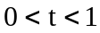, 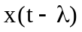 and 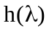 overlap as shown in Fig. (a).
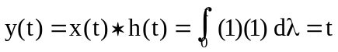
0
(a)
1
t-1
●
2
t
-1
1
x(t - )
h()

For 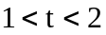, and overlap as shown in Fig. (b).

For 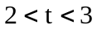, and overlap as shown in Fig. (c).
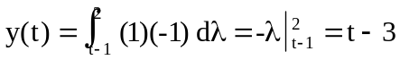

0
(c)
1
t-1
●
2
t
-1
1
0
(b)
1
t-1
●
2
t
-1
1
Therefore,
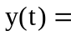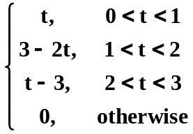

- For 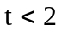, there is no overlap. For 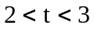, 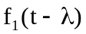 and 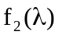 overlap, as shown in Fig. (d).
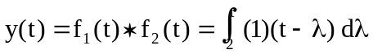
0
(d)
f₁(t - )
f₂()
●
2
3
4
5
1
1
t
t-1
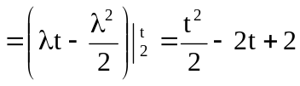
0
(e)
●
2
3
4
5
1
1
t
t-1

For 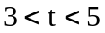, and overlap as shown in Fig. (e).
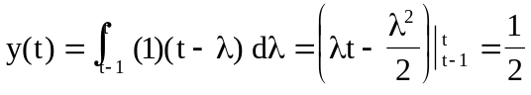

For 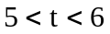, the functions overlap as shown in Fig. (f).
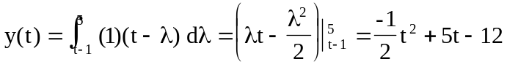
t
t-1
0
(f)
●
2
3
4
5
1
1

Therefore,
